CarePilot's Golden Path — explained

1. First, understand the problem
Imagine you are learning how to build an AI agent for a hospital. Your task is to build a system that helps ensure cancer survivors do not miss their planned follow-up care.
Before CarePilot can do anything, the patient's record must already exist. The synthetic patient register and appointment list must be loaded, and the patient must be identifiable by their hospital patient identifier (MRN). If a record cannot be matched, CarePilot raises an exception rather than silently creating a patient.
The Golden Path is the complete patient story CarePilot must handle successfully, from a missed booking to a patient response, human review, a doctor's decision and the next follow-up task.
CarePilot automates routine coordination while keeping the coordinator and oncologist in control of decisions that require human judgement.
The sprint uses synthetic patient data. The WhatsApp channel and hospital record are simulated, while the backend workflow and specified Sarvam AI calls are real.

2. The Golden Path, step by step
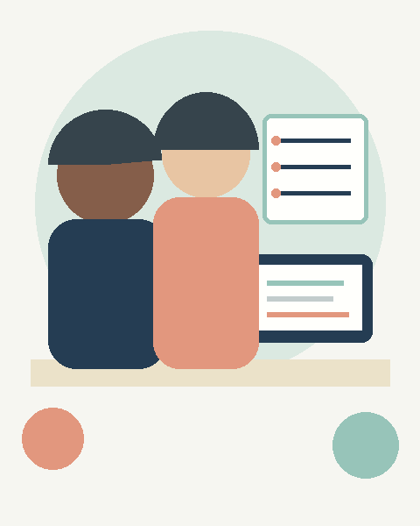 | Step 0 — Make sure the patient is in the system  The coordinator loads the synthetic patient register and appointment list. CarePilot checks the patient identifier (MRN). Duplicate, malformed or unmatched records are flagged for review; the system must not silently create an uncertain patient record.  Why? CarePilot must know exactly which patient and follow-up task it is handling before taking action.

Step 1 — Confirm the patient's follow-up plan
The coordinator confirms the signed-off survivorship plan, enters the relevant treatment details and treatment end date, checks the required identifiers, and records consent for automated messaging. CarePilot then creates follow-up order cards with due dates, responsible owners and backup contacts. No order cards are created before the plan is confirmed.
Why? The plan defines what needs to happen; order cards turn it into work that can be tracked.

 | Step 2 — Detect that the appointment has not been booked  At 7:00 a.m., the rules engine checks the follow-up schedule. If the visit is due in seven days and no booking is recorded, the G0 rule raises a gap event. This is a deterministic rule, not an AI decision. The event is logged, and running the same check again must not create a duplicate gap.  Why? The rules engine identifies the coordination gap consistently and records it for action.

Step 3 — The agent selects and sends an allowed reminder
At 7:30 a.m., the agent receives the gap event and checks the current patient state and autonomy policy. It must not send a message if:
• Consent for automated messaging is missing.
• Agent messaging is switched off.
• The patient is paused or closed.
• A handover is already open.
If messaging is permitted, the agent sends an approved Kannada or Hindi booking reminder with three buttons: Booked, Please help me book, and I can't come.
The agent records the action and its reason code in the audit trail, along with the trigger, rule, task, outcome, autonomy mode, policy version and template version.
The Patient page displays Next planned action—for example, “Await patient reply.” This field updates when the patient responds or the workflow state changes.
Why? The agent uses the current context to select a permitted action rather than blindly following a fixed sequence. It cannot invent its own message or override safety rules.

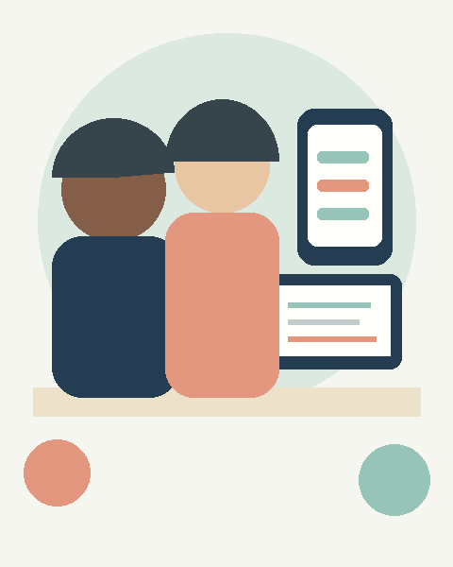 | Step 4 — The patient replies with a button and a message  The patient taps Booked and adds a message in Hindi: “I will come on Saturday. But there has been pain at the operation site since last week.” The same reply is also tested as a pre-recorded voice note. These are two separate inputs. The Booked button updates the visit card directly, without an AI call. The free-text or voice message is processed separately.  Why? A structured button response can update the workflow directly, while free text may contain information that needs a different and safer handling path.

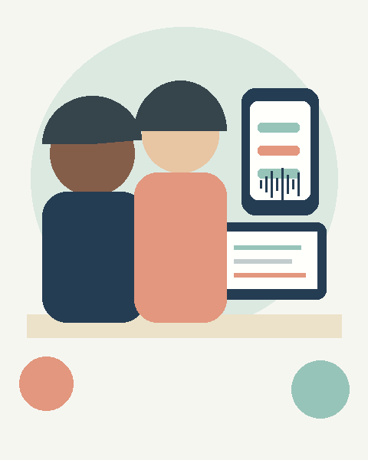 | Step 5 — Sarvam processes the free-text or voice reply  For voice, Saaras v3 transcribes the recording. Sarvam-30B processes the text and translation and returns one flag: Health matter = YES or NO. It does not assess severity, diagnose or recommend treatment.  If YES, uncertain, timeout or error: CarePilot takes the safe path, opens a handover, sends a fixed acknowledgement and blocks further automated messages.  If NO: the reply becomes an approve-first proposal showing the translation and a draft intent. The coordinator must review and approve or reject the proposal. Routine reminders remain on hold until that decision is recorded. The free-text reply cannot independently change the patient's workflow state.  Why? AI helps route the message to the appropriate review path; it does not decide what the health concern means. Even if the model fails to recognise a concern, the unflagged path still requires human review.

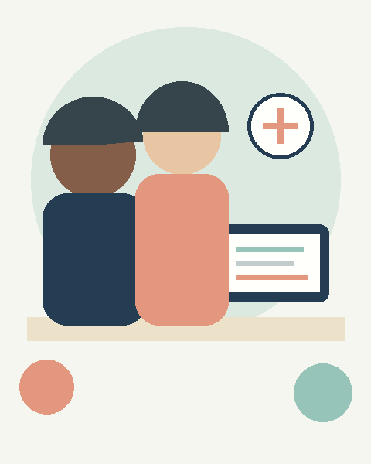 | Step 6 — The agent stops and hands over  When a health matter is flagged, the coordinator sees the patient's original words, English translation, audio and source.  The agent sends no further messages while the handover remains open. The send-layer safety check enforces this block, even if another workflow attempts to send a reminder.  The handover review is due within one working day; a missed deadline follows the configured escalation process.  Why? The system must not continue routine automation when a patient may need human attention.

Step 7 — The coordinator and doctor take control
Gate 1 — Coordinator review: the coordinator chooses whether to send the concern to the doctor, call the patient first, or close it as nothing clinical. This is due within one working day; missed deadlines escalate according to the configured cover process.
Gate 2 — Doctor's decision: the doctor sees the patient's words, translation and source, then explicitly chooses Urgent or Routine. Nothing is pre-selected, and AI does not suggest urgency. The doctor's decision is due within one working day, with escalation to the doctor's cover if missed.
Gate 3 — Doctor's instruction: the doctor records the instruction in the simulated hospital record.
If Urgent is selected, the coordinator calls the patient the same day; if unavailable, the coordinator's cover takes over.
Why? Coordinator review, the doctor's decision and the doctor's instruction are separate human-controlled steps. AI does not replace any of them.

Step 8 — Create the next task and resume follow-up
Suppose the doctor records an instruction for a surgical-site review within seven days. CarePilot creates a new order card with a department owner, backup and a two-working-day booking deadline. It sends an approved booking message the same day. The coordinator closes the handover only after the appropriate human process is complete. Closure requires a named person and a recorded reason. Only after closure does routine automated follow-up resume. The agent cannot close the case by itself.
Why? Resolving the handover must lead to a tracked next action, not leave the patient stranded.

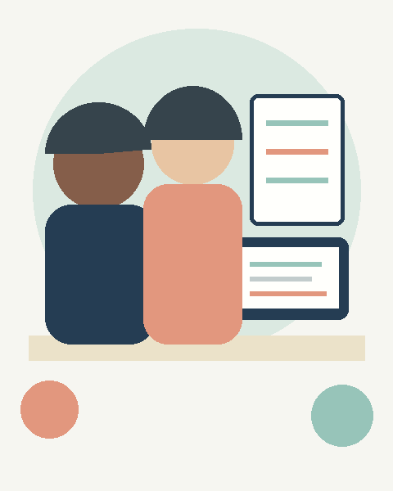 | Step 9 — Record and measure everything  CarePilot records each important action, including who or what acted, the trigger, reason code, policy and template versions, outcome and any human intervention. The system calculates measures such as handover response time. Sprint results are labelled synthetic: they demonstrate that the calculations work, not that clinical outcomes have improved.  Why? The team must be able to explain and audit what happened at every stage.

3. Where exactly is the agent's reasoning and planning?
The agent is not simply a chatbot responding to messages. It participates in a controlled workflow, but not every step involves AI reasoning.
Situation | What CarePilot does | Type of intelligence
Appointment not booked | Detects the gap at T−7 | Deterministic rule
Patient is eligible for a reminder | Checks policy and selects an allowed action | Constrained agent
Patient taps Booked | Updates the visit card | Deterministic workflow
Patient mentions a health concern | Identifies the health mention and routes the case | AI classification + safety rule
Reply is not flagged | Creates a proposal, holds routine reminders and requests coordinator review | AI + human approval
Doctor reviews the concern | Doctor chooses Urgent or Routine | Human judgement
Doctor enters an instruction | Creates the next order card | Human decision + deterministic workflow
Handover is closed | Resumes routine follow-up | State-machine transition
Example of context-aware agent reasoning
Suppose the rules engine detects the same gap: a follow-up appointment has not been booked.
- Patient A — No previous contact: Consent is valid, messaging is enabled and there is no open handover. The agent selects the approved booking reminder.
- Patient B — Messaging is paused: The patient has requested a pause, and the pause is active. The agent does not send the reminder.
- Patient C — A handover is already open: The patient previously mentioned a health concern, and a coordinator has not yet closed the handover. The send-layer policy blocks the reminder.
The detected gap is identical, but the permitted action differs because the patient state differs. The rules engine enforces consent, pause, handover and other safety restrictions. The agent's selected action, reason code and next planned action should be recorded.

4. What if the AI gets it wrong?
The design must remain safe even when the language model makes a mistake.
- Health matter flagged YES: open a handover and stop automated messaging.
- Model uncertain, times out or fails: take the safe handover path.
- Health matter flagged NO: create an approve-first proposal and hold routine reminders until the coordinator decides.
- Coordinator has not closed a handover: block every automated send attempt.
- Doctor has not made an explicit choice: do not allow the decision to be submitted.
- Handover closure is attempted: require a named person and a recorded reason.
The sprint should test all of these conditions, including the unflagged variant, a blocked send during an open handover, a Sarvam timeout, the doctor's mandatory choice and the human closure requirements.
The important lesson is that safety must be enforced by the system's rules and state transitions—not merely by asking the AI to behave responsibly.

5. How would you know the Golden Path works?
☐ The patient register is loaded, the patient exists, the follow-up plan is confirmed and consent is checked.
☐ The G0 rule detects the unbooked appointment.
☐ The agent checks policy, selects a permitted action, records its reason code and updates the next planned action.
☐ Only an approved message is sent when sending is permitted.
☐ A button tap updates the booking state without an LLM call.
☐ Real Sarvam calls process the specified text and voice replies.
☐ Both flagged and unflagged reply paths work correctly.
☐ An unflagged reply becomes a proposal, and routine reminders remain on hold until the coordinator decides.
☐ A health mention, model timeout or error triggers the safe handover path.
☐ All send attempts are blocked while a handover is open.
☐ The coordinator and doctor make explicit decisions, with deadlines and escalation working correctly.
☐ An urgent decision triggers a same-day coordinator call, with cover available if required.
☐ The doctor's instruction creates a new order card and an approved booking message is sent.
☐ Handover closure requires a named person and reason; routine follow-up resumes only after closure.
☐ The audit trail records the complete sequence and the relevant measures update.
If you remember only one thing: CarePilot's Golden Path proves that AI can automate routine patient coordination, respond to changing patient states, recognise when human attention may be needed, stop safely, and resume the workflow after the required human decisions. The differentiator is the complete, auditable loop—not simply sending an AI-generated reminder.

